Eblast – A Prototype Emergency Blast Expert System

J.M. Dewey and D. J. McMillin
Dewey McMillin & Associates Ltd
Suite 100, 1741 Feltham Road
Victoria, B. C. Canada V8N 2A4

Abstract

At MABS15 the authors (Dewey, McMillin and van Netten^{[1]}) described the design concept of EBlast, an expert system to assist those who must take action in emergencies involving explosive hazards. The prototype version of EBlast has been developed and the program is available for customization and practical application. This presentation will show where it was necessary to modify the original design, and will compare the information provided by EBlast with results from actual explosive incidents.

Introduction

Some years ago, Dewey McMillin & Associates Ltd introduced the AirBlast expert system. AirBlast provides a considerable amount of information about the physical properties of blast waves from free-air, surface burst and height-of-burst explosions, but requires the input of an exact description of an explosive source, its height of burst and the atmospheric conditions. In an explosive emergency, a precise description of the explosive source is rarely available, and the output physical properties of the blast wave must be translated into injury and damage criteria. EBlast is an expert system that accepts imprecise or “fuzzy” information about an explosive source as input, and outputs information about the likely injury and damage ranges should an explosion occur in a variety of urban environments.

Analysis of a database containing information about a large number of unplanned explosive incidents, showed that the largest number of deaths and injuries were caused by solid chemical explosives detonated in urban environments. These were usually in the form of terrorist devices and military munitions. It was therefore decided to concentrate on these two types of sources in the prototype version of EBlast. The principal terrorist devices are vehicle, pipe and package bombs. The EBlast interface allows the user to select, via menus, a wide range of such devices, either in specific form, such as a particular vehicle model, or in generic form, such as “a medium sized van”. For the chosen device, EBlast assigns an appropriate explosive charge mass, which can be altered easily by the user if thought to be invalid. Examples of the “Explosive Device” menus are shown as figure 1.

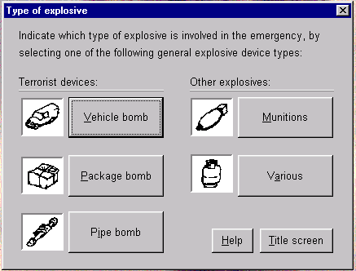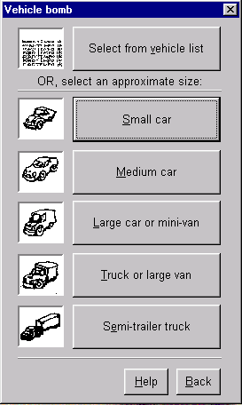

Figure 1. EBlast Explosive device menu (top) and vehicle bomb sub-menu (bottom)

Damage/Injury Criteria

Approximately twenty different explosive damage and injury effects were identified, ranging from major damage to concrete structures to temporary hearing loss. For each effect, the literature was searched to find the best available information relating the blast effect to a distance from a known charge size. The distance was then related to a peak pressure and a pressure impulse, calculated, using AirBlast. The damage/injury criteria for each blast effect were calculate and recorded in the form of a pressure-impulse relationship, such as that shown in figure 2. Each pressure-impulse relationship was translated to a distance charge-mass relationship for use in Eblast.

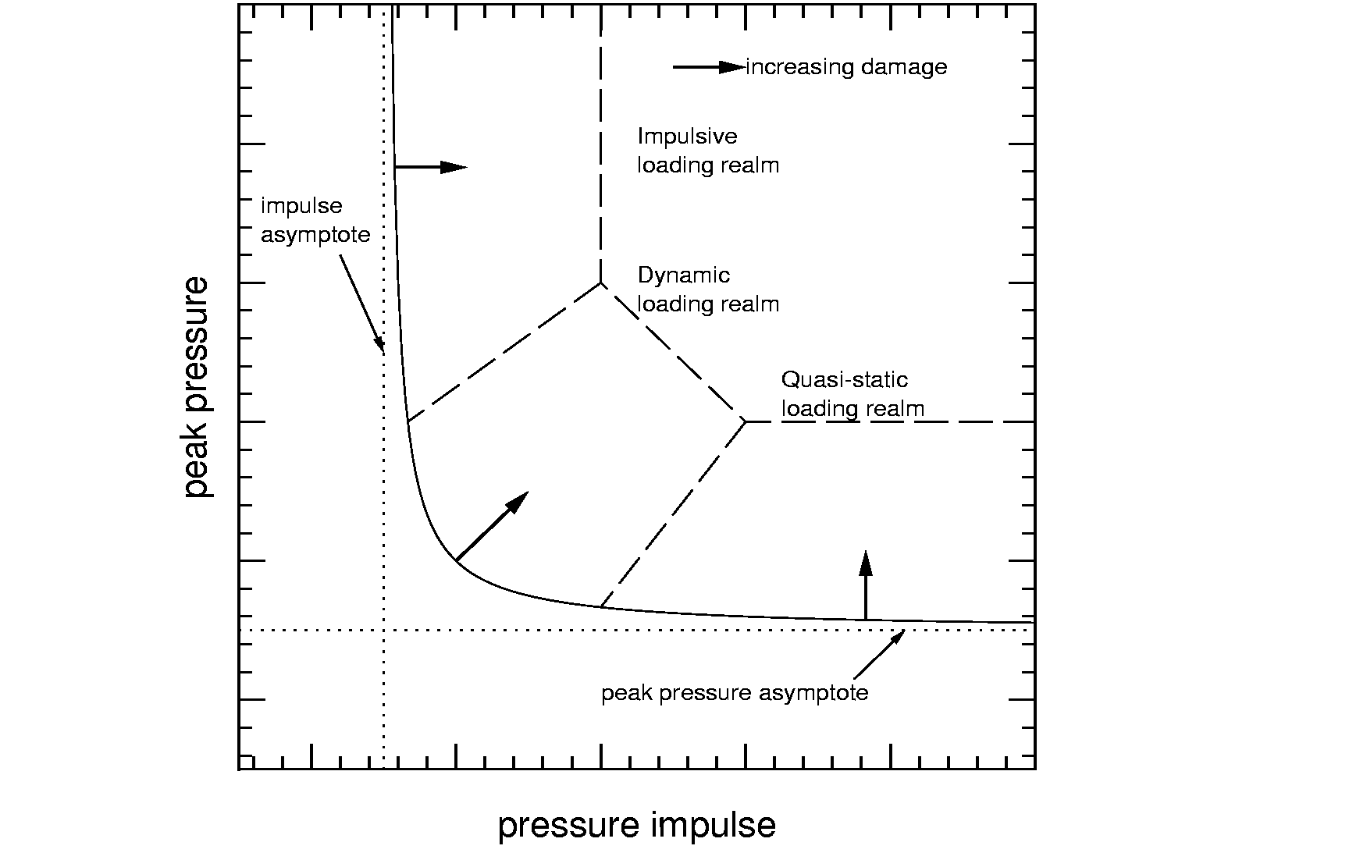

Figure 2. Pressure-impulse damage criterion curve. A curve similar to this can be drawn for most types of damage or injury caused by blast waves. If the point representing the pressure and impulse at a certain distance from an explosion falls above the hyperbola-type curve, the damage or injury is expected to occur.

Effects of Urban Environments

Most terrorist threats occur in cities in which the urban environment may have a significant effect on the blast propagation and the limiting distances for the different blast effects. The blast-effects distances calculated by EBlast, based on the assumed charge mass of a surface burst explosion, must be modified to account for different urban environments. In the original design of the program, as described at MABS15, it had been planned to use information about urban environments in the form of street width (W),
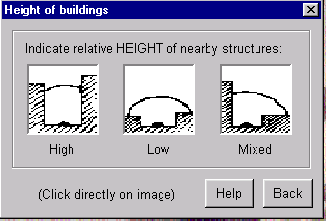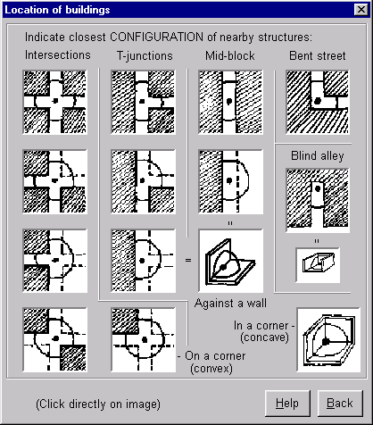

Figure 3. Urban environment menus for choosing typical horizontal and vertical layouts.

building height (H) and building density (D), extracted from geographical information systems (GISs). Unfortunately, for most cities, this information is not available in a format that can be accessed from a computer file. In the prototype version it is therefore necessary for the EBlast user to provide information about the environment of the explosive device. This is done by menu selection from a range of about 45 different urban
environments, providing information about the immediate closeness of the device to a building and the type of building height and layout in the vicinity, as shown in figure 3.

Numerical simulation, using the AWAF code (van Netten and Dewey^{[2]}), has been used to determine the influence of the various urban environments on the blast wave properties as functions of distance, for a range of charge sizes. Each simulation provides the variation with distance of peak overpressure and pressure-impulse. These variations are compared with the corresponding variations for a surface-burst charge in a free-field environment, provided by AirBlast. The ratios of the pressure and impulse at each distance are calculated. The free-field pressure and impulse versus distance relationships are then modified by two factors, E₁ and E₂. E₁ essentially modifies the charge size to account for effects close to the explosive source, and E₂ modifies the pressure and impulse relationships at extended distances from the source so as to best match the modified relationships in the specified urban environment. The result of such a manipulation is shown in figure 4.

Figure 4. Pressure-distance relationship modified to account for an urban environment. The solid curve shows the variation of the enhancement factor obtained by comparing the peak pressure in an urban environment (○) with that from a free-field surface burst (●), at the same distance. The free-field data are modified, using factors E₁ and E₂, to produce the pressures used by EBlast (■).

Computer Interface

Because EBlast is designed for use in emergency situations when haste is of great importance, the input and output interfaces have been made as simple as possible. Two forms of output are available. The first shows the expected limiting blast-effects distances numerically and graphically as a bar chart (figure 5). “Clicking” on a bar immediately displays an explanation and information about the particular blast effect, to help guide the emergency personnel using the program. This information can be upgraded easily to meet the specific needs of the user.
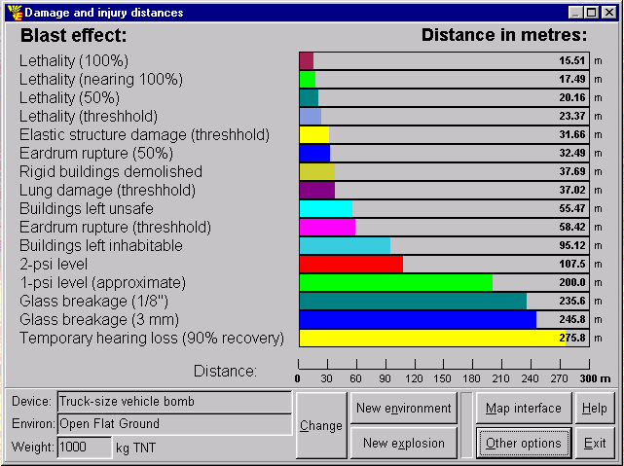
Figure 5. Numerical/bar chart output. The charge mass and units can be changed easily.

The second method of displaying the information about the blast-effects distances, allows the distances to be overlaid as contours on city maps that can be stored in a variety of GIS formats (figure 6). This allows bomb squads to immediately determine appropriate evacuation limits.

Program Evaluation

The accuracy of the blast-effects distances calculated by EBlast has been evaluated by comparing them with the reported effects from several terrorist or accidental explosions. One such comparison is shown in figure 7. The effects distances also compare well with those recommended by the US Bureau of Alcohol, Tobacco and Firearms (ATF) for vehicle bombs, although these do not allow for effects of urban environments. A report detailing the comparisons of EBlast predictions with the observations at several large scale explosive incidents, can be obtained on request to the authors.

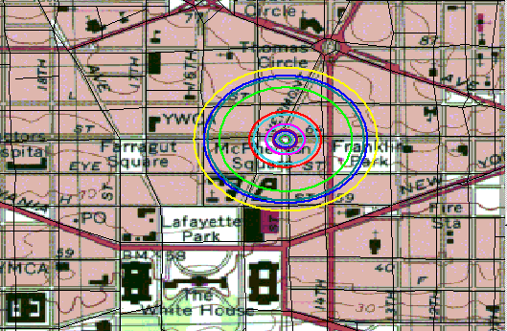
Figure 6. Contours of blast-effects distances overlaid on a city map from a geographical information system (GIS)

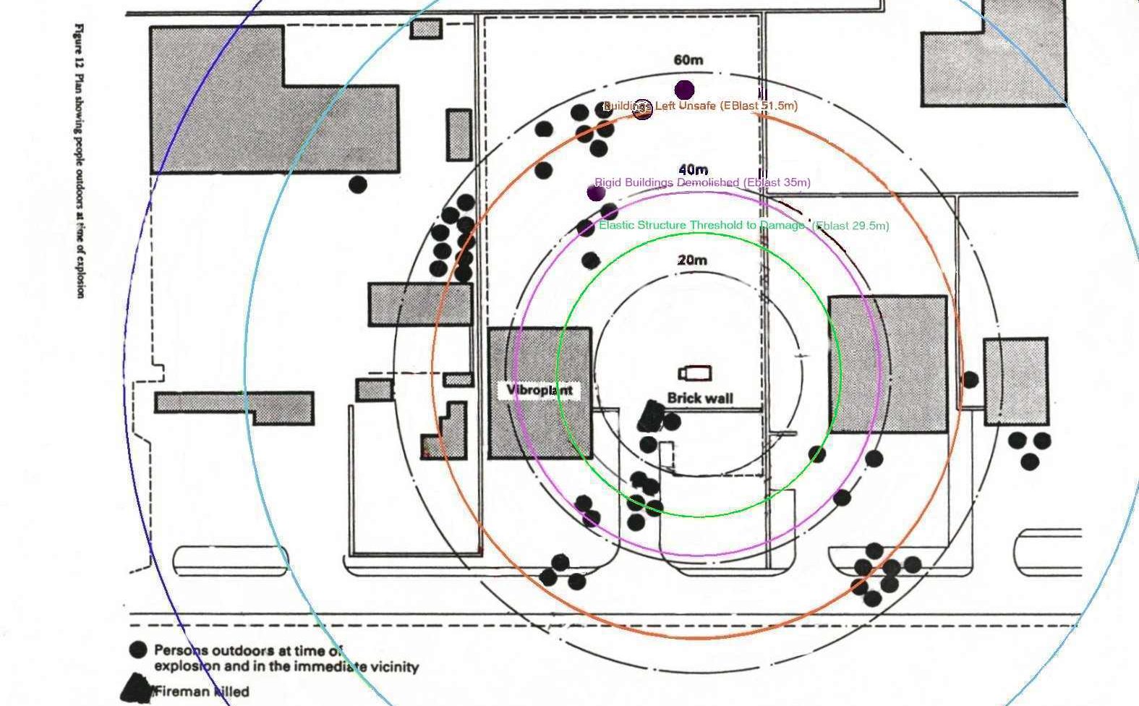
Figure 7. EBlast blast-effects contours overlaid on the environment of the 1989 Peterborough explosion for program evaluation.

Additional Applications

In addition to its use by bomb squads in emergencies, the EBlast expert system serves as a valuable tool for training, planning and rapid postmortem evaluations. International Government agencies have expressed concern that EBlast could be used by terrorists. Several security features have therefore been built into the program. The program is only licensed to approved agencies, and can only be installed on identified computers. The files cannot be copied or transferred to another machine.

Acknowledgements

Dewey McMillin & Associates Ltd gratefully acknowledge the financial assistance of the British Columbia Science Council and the University of Victoria Innovation Development Centre in the development of EBlast.

References

[1] Dewey, J. M., McMillin, D. J. and van Netten, A. A., 1997, EBlast – An Emergency Blast Expert System, Proc. 15th Int. Symp. Mil. Aspect Blast and Shock, MABS15, Defence Res. Est. Suffield, 71-76

[2] van Netten, A. A. and Dewey, J. M., 1997, Real Time Presentation of Numerical Simulations, Proc. 15th Int. Symp. Mil. Aspect Blast and Shock, MABS15, Defence Res. Est. Suffield, 503-508

